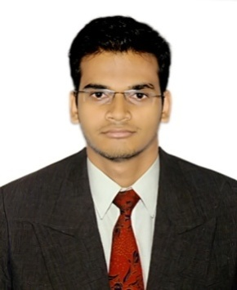
BIPLAB SAGAR MANSINGH
At- Konark nagar,
Po- Pallahat, dist- khordha
pin-752056
EMAIL ID- biplabmansingh0001@gmail.com
CONTACT NO- 08984791926
CAREER OBJECTIVE-

Seeking a responsible job with an opportunity for professional challenges so as to enhance my skills in a dynamic and fast paced workplace.
PROFESSIONAL EXPERIENCE-

- Designation: Accounts Executive
- Company- E-Zone Projects Pvt Ltd
- Time period- (July 2016 to till date)
- Responsibilities- Managing daily accounts, receivables and payables and maintaining Day Today account records.
ACADEMIC-

COURSE | BOARD/INSTITUTION | YEAR OF PASSING | CGPA/PERCENTAGE (%)
MBA (Finance and Marketing) | BPUT/NIST | 2014-2016 | 6.60
M.Com (Finance) | Berhampur University | 2014 | 66%
B.Com (Accounts) | Prananath (auto.) college | 2012 | 63.8%
+2 Commerce | CHSE/Prananath (auto.) college | 2009 | 69%
10th | BSE | 2007 | 62%
SUMMER INTERNSHIP PROJECT-

Name of the organization- Hindustan Coca-Cola Beverages Limited.
Project description:-
Project title- Working Capital Management.
Department- Finance
Period - 45 days
Responsibilities-(i)Maintaining inventory records
(ii) Accounts receivable and payable
(iii) Cash management
COMPUTER PROFICIENCY-

- PGDCA
- TALLY 9.0
- In addition, working knowledge on MS-Office and Internet
PERSONAL DETAILS-

- Father’s name: Shri DebendraKumar Mansingh.
- Date of Birth: 5th December, 1992.
- Marital status: Unmarried
- Nationality: Indian
- Strengths: Disciplined, time-bound, adaptive.
- Languages known: English, Hindi, Oriya.

Date:
Place: Biplab Sagar Mansingh

